Ques 1: Foregone Solution

Problem

Someone just won the Code Jam lottery, and we owe them **N** jamcoins! However, when we tried to print out an oversized check, we encountered a problem. The value of **N**, which is an integer, includes at least one digit that is a 4... and the 4 key on the keyboard of our oversized check printer is broken.

Fortunately, we have a workaround: we will send our winner two checks for positive integer amounts A and B, such that neither A nor B contains any digit that is a 4, and A + B = **N**. Please help us find any pair of values A and B that satisfy these conditions.

Input

The first line of the input gives the number of test cases, **T**. **T** test cases follow; each consists of one line with an integer **N**.

Output

For each test case, output one line containing Case #x: A B, where x is the test case number (starting from 1), and A and B are positive integers as described above.

It is guaranteed that at least one solution exists. If there are multiple solutions, you may output any one of them. (See "What if a test case has multiple correct solutions?" in the Competing section of the [FAQ](https://codingcompetitions.withgoogle.com/codejam/faq). This information about multiple solutions will not be explicitly stated in the remainder of the 2019 contest.)

Limits

1 ≤ **T** ≤ 100.  
Time limit: 10 seconds per test set.  
Memory limit: 1GB.  
At least one of the digits of **N** is a 4.

Test set 1 (Visible)

1 < **N** < 105.

Test set 2 (Visible)

1 < **N** < 109.

Solving the first two test sets for this problem should get you a long way toward advancing. The third test set is worth only 1 extra point, for extra fun and bragging rights!

Test set 3 (Hidden)

1 < **N** < 10100.

Sample

|  |  |
| --- | --- |
| Input | Output |
| 3  4  940  4444 | Case #1: 2 2  Case #2: 852 88  Case #3: 667 3777 |

In Sample Case #1, notice that A and B can be the same. The only other possible answers are 1 3and 3 1.

Ques 2: You Can Go Your Own...

Problem

You have just entered the world's easiest maze. You start in the northwest cell of an **N** by **N** grid of unit cells, and you must reach the southeast cell. You have only two types of moves available: a unit move to the east, and a unit move to the south. You can move into any cell, but you may not make a move that would cause you to leave the grid.

You are excited to be the first in the world to solve the maze, but then you see footprints. Your rival, Labyrinth Lydia, has already solved the maze before you, using the same rules described above!

As an original thinker, you do not want to reuse any of Lydia's moves. Specifically, if her path includes a unit move from some cell A to some adjacent cell B, your path cannot also include a move from A to B. (However, in that case, it is OK for your path to visit A or visit B, as long as you do not go from A to B.) Please find such a path.

In the following picture, Lydia's path is indicated in blue, and one possible valid path for you is indicated in orange:

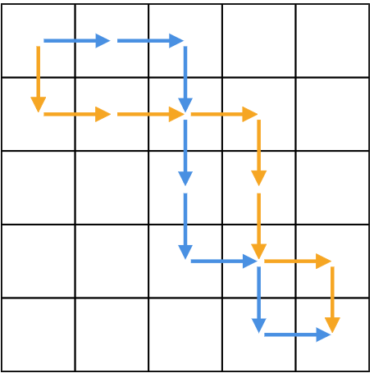

Input

The first line of the input gives the number of test cases, **T**. **T** test cases follow; each case consists of two lines. The first line contains one integer **N**, giving the dimensions of the maze, as described above. The second line contains a string **P** of 2**N** - 2 characters, each of which is either uppercase E (for east) or uppercase S (for south), representing Lydia's valid path through the maze.

Output

For each test case, output one line containing Case #x: y, where x is the test case number (starting from 1) and y is a string of 2**N** - 2 characters each of which is either uppercase E (for east) or uppercase S (for south), representing your valid path through the maze that does not conflict with Lydia's path, as described above. It is guaranteed that at least one answer exists.

Limits

1 ≤ **T** ≤ 100.  
Time limit: 15 seconds per test set.  
Memory limit: 1GB.  
**P** contains exactly **N** - 1 E characters and exactly **N** - 1 S characters.

Test set 1 (Visible)

2 ≤ **N** ≤ 10.

Test set 2 (Visible)

2 ≤ **N** ≤ 1000.

Test set 3 (Hidden)

For at most 10 cases, 2 ≤ **N** ≤ 50000.  
For all other cases, 2 ≤ **N** ≤ 10000.

Sample

|  |  |
| --- | --- |
| Input | Output |
| 2  2  SE  5  EESSSESE | Case #1: ES  Case #2: SEEESSES |

In Sample Case #1, the maze is so small that there is only one valid solution left for us.

Sample Case #2 corresponds to the picture above. Notice that it is acceptable for the paths to cross.